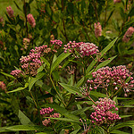

Landscaping with New York State Native Plants

Spring 2015

Prepared by the Town of Brighton NY Conservation Board

Table of Contents:

Perennials Suitable for Wet and/or MoistSites…………………………………………………………..2

Perennials Suitable for Medium and/or DrySites………………………………………………………..6

Vines and Groundcover………………………………………………………………………………………7

Shrubs…………………………………………………………………………………………………………...9

Small Trees……………………………………………………………………………………………………12

Large Trees……………………………………………………………………………………………………15

Native Trees to Avoid……………………………………………………………………………………….19

Invasive or Potentially Invasive: Avoid/Remove………………………………………………………20

References and Image Citations……………………………………………………………………...22, 23

Like the local plants of any region, the native plants of New York State have evolved together for thousands of years, relying on and supporting each other in our regional ecology. Native plants attract birds and other pollinating fauna, contributing to a dynamic and healthy ecosystem, and can often be used in landscaping instead of less beneficial exotic species.

The following document includes lists of plants that are native to New York State, are aesthetically pleasing, and have marked value for the surrounding wildlife. These lists include only a fraction of the good native plant choices you could make for your project. Many more can be found in the source materials cited in the References section at the end of this document.

Also included in this document is a list of native species to avoid at this time due to their susceptibility to disease and insect predation, as well as a list of non-native invasive species still commonly used by New York State landscapers.

Perennials Suitable for Wet and/or Moist Sites (alphabetical by Latin species name)
Picture | Name | Height | Soil Moisture | Light | Landscape Functions | Ecological Functions
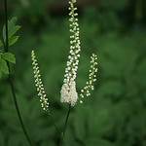 | Black Cohosh  Actaea racemosa, Cimicifuga racemosa | 3’-5’ | Wet to dry | Partial sun to shade | Fragrant summer blossoms | Food for caterpillar larvae, bees; excellent source of nectar.
 | Swamp Milkweed  Asclepias  incarnata | 2’-4’ | Wet to medium | Sun to partial sun | Fragrant white pink, mauve flower clusters, July to August | Critical to life cycle of Monarch Butterfly, providing food to caterpillar stage; nectar for butterflies, bees, hummingbirds, other pollinators.
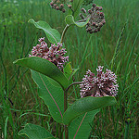 | Common Milkweed  Asclepias syriaca | 3’-5’ | Moist to dry | Sun | Very fragrant large flower clusters late June to early August | As above.
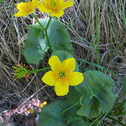 | Marsh Marigold  Caltha palustris | 6”-1’ | Wet to moist | Sun to shade | Early spring flowers | Pollinators, birds
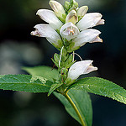 | Turtlehead  Chelone glabra | 2’-3’ | Wet to medium | Sun to partial shade | Flowers late summer to early autumn | Pollen and or nectar:Baltimore Checkerspot Butterfly larvae, hummingbirds
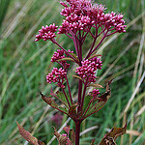 | Spotted Joe-Pye Weed  Eupatorium maculatum, Eutrochium maculatum | 3’-6’ | Wet to medium | Sun to partial shade | Large showy flower clusters August -September | Attract high insect activity, benefits pollin-ators; seed is a small nutlet, a food souce to water-fowl, song-birds, gamebirds, small mammals.
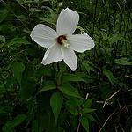 | Marsh Mallow, Rose Mallow  Hibiscus moscheutos | 4’-7’ | Wet to moist | Sun to partial shade | Late summer; deciduous ground cover | Nectar and/or pollen source, hummingbirds, bees; larval food for caterpillars.
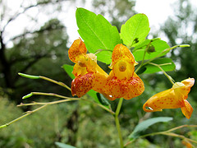 | Jewelweed, Touch-me-not  Impatiens capensis | 2’-5’ | Wet to moist | Partial sun to shade | Late summer;  deciduous ground cover | Cover for wildlife; pollen/ nectar; bees, excellent hummingbird plant
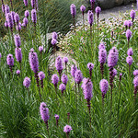 | Blazing Star, Gayfeather  Liatris spicata | 2’-4’ | Moist to medium | Sun | Flowers in summer | Nectar/pollen source; excellent nectar for butterflies; larval food; food for wintering birds.
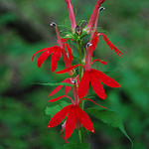 | Cardinal Flower  Lobelia cardinalis | 2’-4’ | Wet to moist | Sun to partial shade | Summer/  fall flowers; deciduous ground cover | Pollen/nectar sourcer;  Beacon for Hummingbirds!
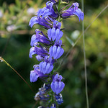 | Great Blue Lobelia  Lobelia siphilitica | 2’-4’ | Wet to medium | Sun to partial sun | Summer/  fall flowers; deciduous ground cover | Pollen/nectar producer;  excellent source of nectar for hummingbirds and nocturnal sphinx moths
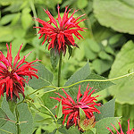 | Beebalm, Oswego Tea  Monarda didyma | 1’-3’ | Moist to medium | Sun to partial shade | Summer  flowers; deciduous ground cover | Hummingbird favorite (especially mildew-resistant “Jacob Cline” cultivar), and butterflies, bees
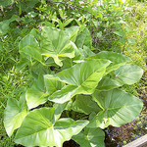 | Arrow Arum  Peltandra virginica | 1’-3’ | Wet | Sun to partial shade | Summer bloosoms | Bees, fish, aquatic insects
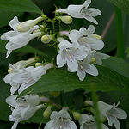 | Foxglove Beardtongue, Talus Slope Penstemon, Smooth Penstemon  Penstemon digitalis | 2’-4’ | Moist to medium | Sun to partial sun | Spring, summer flowers; deciduous ground cover | One of the summer pollinator friendly plants
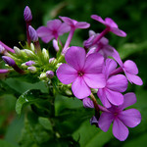 | Phlox  Phlox paniculata | 3’-5’ | Moist to medium | Sun to partial sun | Summer flowers; deciduous ground cover | Pollen; nectar for the hummingbird sphinx moth; cover for wildlife
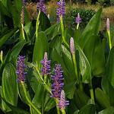 | Pickerelweed  Pontederia cordata | 2’-3’ | Wet; root mass must be under water year- round | Sun | Fragrant blooms, summer to autumn | Waterfowl, dragonflies, pollinators; food for caterpillars; nest sites for birds
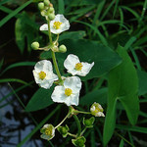 | Arrowhead  Sagittaria latifolia | 2’-3’ | Very moist to shallow water | Sun | Flowers in summer | Pollinators; ducks, turtles; wildlife eat the seeds and tubers.
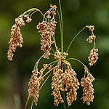 | Woolgrass, Marsh Bulrush  Scirpus cyperinus | 3’-5’ | Wet soil/ shallow water, along shoreline, up to 1.5’depth | Sun to partial shade | Blooms summer to early autumn | Cover for wildlife; waterfowl, Dion Skipper butterfly larvae.
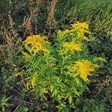 | Canada Goldenrod  Solidago canadensis | 3’-6’ | Wet to dry | Sun | Flowers August through October; deciduous ground cover | Tall, rigid per-ennial provides dense summer and winter cover; supplies seed, nectar, pollen, larval food for 115 species of caterpillars.
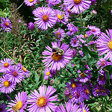 | New England Aster  Aster novae-angliae,  Symphyotrichum novae-angliae | 3’-6’ | Moist to medium | Sun | Flowers late August to October; deciduous ground cover | Butterflies, bees, high value to pollinators; improve insect diversity and diversify grass-land habitat;  (cont’d below)
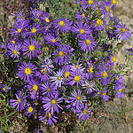 | New York Aster  Aster novi-belgii,  Symphyotrichum novi-belgii | 18”-5’ | Moist to medium | Sun | Flowers late summer to early autumn | Asters also benefit songbirds, grouse, turkey, small mammals, rabbits and deer; host plant for many caterpillars.

Perennials Suitable for Medium and/or Dry Sites (alphabetical by Latin species name)
Picture | Name | Height | Soil Moisture | Light | Landscape Function | Ecological Function
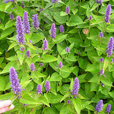 | Anise Hyssop  Agastache foeniculum | 3’-6’ | Medium to dry | Sun to partial shade | Summer flowers | Butterflies, hummingbirds, other pollinators.
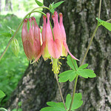 | Columbine  Aquilegia canadensis | 1’-3’ | Medium to dry | Sun to partial shade | Blooms early spring to mid-summer; deciduous ground cover | Pollen, nectar; bees, butterflies, excellent hummingbird plant.
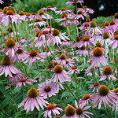 | Purple Coneflower  Echinacea purpurea | 2’-3’ | Medium to dry | Sun to partial sun | Flowers summer to early autumn; deciduous ground cover | Great source for midsummer nectar and pollen; goldfinches flock to the seeds in the fall.
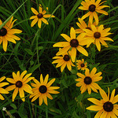 | Black-eyed Susan  Rudbeckia hirta | 1’-3’ | Medium to dry | Sun to partial sun | Flowers summer to early autumn | Nectar for many butterflies and other summer insects; food for caterpillars; great seed source in the fall.

Vines and Groundcover (alphabetical by Latin species name)
Picture | Name | Height | Soil Moisture | Light | Landscape Function | Ecological Function
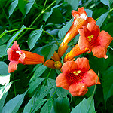 | Trumpet Vine, Trumpet Creeper  Campsis radicans | 36’-72’ | Moist to dry | Sun | Large trumpet shaped blooms summer; large, vigorous space- filling vine | Provides much nectar and pollen for hummingbirds and bees; nesting sites.
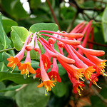 | Trumpet Honeysuckle  Lonicera sempervirens | 12’-36’ | Moist | Sun | Spring through summer flowers. | Hummingbirds regularly visit, and bumblebees; cardinals nest in vines; berries in the fall for cardinals, bluejays; larval food for Spring Azure Butterfly.
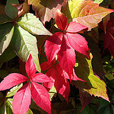 | Virginia Creeper  Parthenocissus quinquefolia | 3’-40’  (Can climb or creep along ground) | Moist to dry | Sun to partial shade | Small blossoms, spring, small berries June, bright  foliage in fall. | Berries for many birds; vines eaten by many animals; cover and shelter; vines provide perches, nesting places and surfaces to find food.
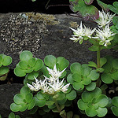 | Woodland Stonecrop  Sedum ternatum | 1”-1’ | Moist to medium | Sun to partial shade | Spring blossoms; evergreen ground cover | Pollinators, larval food for Variegated Fritillary Butterfly.
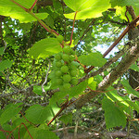 | Riverbank grape  Vitis riparia | 35’-72’ | Moist to dry | Sun to shade | Woody vines support the green small flowers, May-July; fruit August-October. | Wild Grape very important for wildlife; many birds nest in the tangles, use the bark to build nests; many birds and mammals depend on the grapes for food.

Shrubs (alphabetical by Latin species name)
Picture | Name | Height | Soil Moisture | Light | Landscape Function | Ecological Function
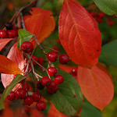 | Red Chokeberry  Aronia arbutifolia,  Photinia pyrifolia | 4'-6' | Wet to Dry | Sun to partial Sun | Spring flowers, fall foliage color | Good all-around wildlife plant; larval food; produces pollen/nectar, cover, nesting sites, food for migrating and winter birds.
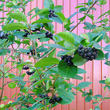 | Black Chokeberry  Aronia melanocarpa, Photinia melanocarpa | 3'-5' | Wet to Dry | Sun to partial Sun | Spring flowers, fall foliage color | Good all-around wildlife plant; pollen and nectar; fruit is food for fall migrant and wintering birds; larval food for caterpillars.
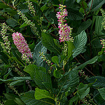 | Summer-sweet  Clethra alnifolia | 2'-5' | Wet to medium | Sun to partial shade | Summer flowers, fragrant; useful along stream-banks. | Cover for wildlife, nesting sites; pollen, nectar for bees, butterflies, hummingbirds; mammals.
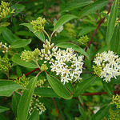 | Silky Dogwood  Cornus amomum | 5'-8' | Wet to medium | Sun to partial shade | Spring flowers, fall fruits and foliage color. | Great resource for pollinators and berry eaters; cover for wild-life, nesting; food for breeding and wintering birds, spring and fall migrating birds; larval food.
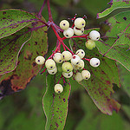 | Gray Dogwood  Cornus racemosa | 5'-8' | Wet to very dry | Sun to partial shade | Spring flowers, white fruits, fall foliage color | Same as for Silky Dogwood, above.
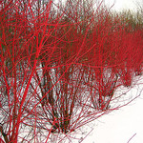 | Red Osier Dogwood, Red Twig Dogwood  Cornus sericea | 5'-8' | Wet to dry | Sun to partial shade | Spring flowering, brightly colored bark in winter. | Cover; berries valuable fall/winter food for birds; larval food.
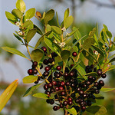 | Inkberry  Ilex glabra | 3'-4' | Wet to medium; prefers acidic soil | Sun to partial shade | Small spring blossoms; good to use for screening. | Excellent nectar and pollen source; cover for wildlife, nesting sites; black fruit for more than 15 species of birds, including wintering birds.
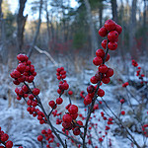 | Common Winterberry  Ilex verticillata | 4'-6' | Wet to medium | Sun to partial shade | Flowers in spring; good fall foliage color; use-ful along stream banks. | As above; additionally red berries on bare stems prvide food for birds throughout winter; plant is DIOECIOUS (one male per several females).
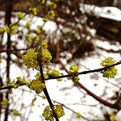 | Northern Spicebush  Lindera benzoin | 6'-10' | Wet to medium | Sun to shade | Early spring flowers, fall color, fragrant, provides shade and cooling. | Spicebush Swallowtail Butterfly larvae, Promethea Silkmoth larvae, berries high in oils for migrating and winter birds: plant is DIOECIOUS.
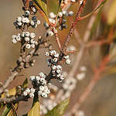 | Northern Bayberry  Myrica pensylvanica,  Morella pensylvanica | 6'-8' | Wet to very dry | Sun to partial shade | Flowers in spring, fall color, fragrant, provides shade and cooling. | Nectar, pollen; cover for wildlife, nesting sites for birds, food for birds and mammals; (host for Columbia Silkmoth larvae.)?
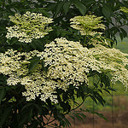 | American Elderberry, Black Elderberry  Sambucus canadensis | 6’-8’ | Wet to dry | Sun to partial shade | Large late spring and summer flower clusters; berries for preserves,wine, and jelly. | Super plant for flowers, and fruit for wildlife! Fast grower.  (Having more than one variety usually fosters cross pollination and more fruit.)
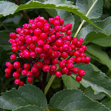 | Red Elderberry  Sambucus racemosa | 6’-8’ | Moist to dry | Partial sun to shade | Late spring large flat flower clusters. | Flowers for pollinators, more than 120 species of birds have been documented feeding on elderberry fruit.
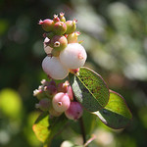 | Common Snowberry  Symphori-carpos albus | 3'-4' | Medium to dry | Sun to partial shade | Early summer flowers. | Pollen, nectar; cover, nesting sites; food for birds, mammals, Hummingbird Moth larvae.  (Alternative to cotoneasters, see below.)
or 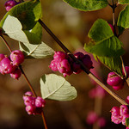 | Coralberry  Symphori-carpos orbiculatus | 3'-4' | Moist to dry | Sun to partial shade | Flowers late spring to early summer | Pollen, nectar; food for birds, food for caterpillars.  (Coralberry and Snowberry are both good native alternatives to the ubiquitous cotoneasters.)
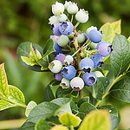 | Highbush Blueberry  Vaccinium corymbosum | 6'-8' | Best in moist acidic soil with high organic content. | Sun | Spring flowers; berries later summer; bright crimson foliage in fall. | Pollen, nectar; abundant food for birds and mammals,includ-ing humans; hosts over 200 species of caterpillars.  Alternative to Burning Bush
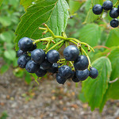 | Arrowwood Viburnum  Viburnum dentatum | 6'-10' | Moist | Sun to partial shade | Flowers late spring to early summer; fall foliage cplor. | Birds, bees, spring azure butterfly larvae  Nectar,pollen; cover,nesting sites; berries . migrating birds; good source of caterpillars for nesting birds.for wintering birds

Small Trees (alphabetical by Latin species name)

Picture | Name | Height | Soil Moisture | Light | Landscape Function | Ecological Function
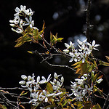 | Common Serviceberry, Downy Serviceberry  Amelanchier arborea | 15'-25' | Moist to dry | Sun to partial shade | Early spring flowers; in June sweet berries. | Birds, pollinators, mammals, special value to native bees.  Amelanchier --- Great group of plants for birds.
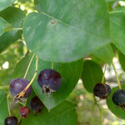 | Shadblow Serviceberry  Amelanchier canadensis | 10'-20' | Wet to medium | Sun to partial shade | Blossoms early spring, fruit early summer | As above.  Fruiting machines!
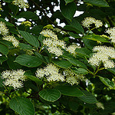 | Pagoda Dogwood,  Alternateleaf Dogwood  Cornus alternifolia | 10'-20' | Moist to medium | Sun to partial shade | Late spring  flowers, fall color, shade; year round interest. | High wildlife value; great source of berries and insects; wintering bird favorite, grouse,  pheasants, wild turkeys; Spring Azure Butterfly larvae.
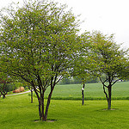 | Washington Hawthorn  Crataegus phaenopyrum | 20’-30’ | Moist to dry | Sun to partial sun | Late spring to early summer, fall color, shade and cooling. | Pollinators; Warblers, Orioles eat the blossoms; food for birds in fall migration; food for caterpillars.
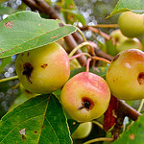 | Sweet Crabapple  Malus coronaria  *Susceptible to rust | 12’-36’ | Moist | Partial shade | White, pink flowers May and June. | Thickets provide nesting sites, shelter, and food for large and small birds, special value to native bees and honeybees, attractive to other pollinators.
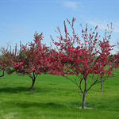 | Sargent Crabapple  Malus sargentii  *Non-native, but non-invasive and resists rust | 6’-8’ | Medium | Sun | Spring flowers, can be used in small spaces. | Attributes as above, and has berries small enough for birds to eat which some hybrids do not.
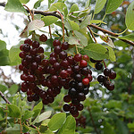 | Chokecherry  Prunus virginiana | 15'-25' | Moist to dry | Sun, tolerant of shade; can be understory tree. | Spring flowers, good fall color, dark fruit August to September; erosion control. | Butterflies, native bees; important wildlife food source, birds and mammals; soil stability; host for various sphinx moth larvae and Columbia silk-moth.
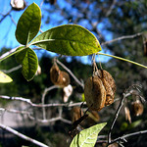 | Hoptree  Ptelea trifoliata | 15'-20' | Wet to dry | Sun to shade | Late spring flowering, yellow fall foliage color; shade and cooling. | Cover for wildlife, nesting sites; nectar attracts butterflies; host for Giant Swallowtail Butterfly larvae; seeds stay on in winter for birds.
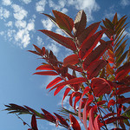 | Smooth Sumac  Rhus glabra | 10'-20' | Medium to dry | Sun to partial shade | Summer flowers, brilliant red fall foliage and fruit; neglected landscape plant. | Both Sumacs important to insects and mammals, and especially feeder adverse birds, like Cedar Waxwings, Northern Flickers, Robins.
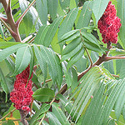 | Staghorn Sumac  Rhus typhina | 15'-30' | Medium to dry | Sun to partial shade | Summer; as above, brilliant fall color unique in the native fall landscape. | Both Sumacs’ nutritious berries are of high value as wildlife food and cover, critical winter food source; support 54 species of caterpillars.
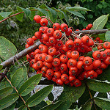 | American Mountain Ash, Northern Mountain Ash  Sorbus americana, Sorbus decora | 12'-36' | Moist to dry | Sun to shade | White spring  flowers, fall color, contrasting bright orange berries;  shade. | Nectar/pollen; feeds many birds, i.e. Robins, Cedar Waxwings, Blue Jays, Evening Grosbeaks, Cardinals; food for mammals, food for caterpillars.
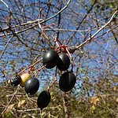 | Nannyberry  Virburnum lentago | 10'-20' | Wet to medium | Sun to partial sun | Spring  flowers, summer berries, fall foliage color, shade and cooling. | Birds, insects, Spring Azure B’fly larvae;  Vireos and Chickadees patrol the sweet smelling blossoms, fruit gone by fall; good nesting sites.

Large Trees (alphabetical by Latin species name)
Picture | Name | Height | Soil Moisture | Light | Landscape Function | Ecological Function
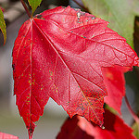 | Red Maple  Acer rubrum  Note: Landscape and Ecological Function same for both Acers listed here. | 40'-60' | Wet to dry | Sun to partial shade | Spring flowering, brilliant fall foliage, sequesters carbon, shade/  cooling. | Cover, pollen and nectar, food for breeding birds, spring and fall migrants, food for 300 insect larvae, and humans.
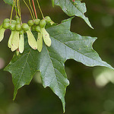 | Sugar Maple  Acer saccharum | 60'-75' | Moist to medium | Sun, tolerant of shade. | Spring flowering;  renown for brilliant autumn color, sequesters carbon. | Birds, bees; seeds, buds, twigs for squirrels; nesting sites for songbirds and  cavity nesting woodpeckers, owls,chickadees
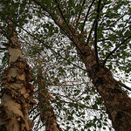 | River Birch  Betula nigra | 40'-70' | Wet to dry; will grow in swamps, low spots, but also on higher ground; fast growing. | Sun to partial sun; a heat tolerant birch. | Spring; of-ten multi- trunked; grey peel-ing bark, ornamental; rain gardens or groupings or as a specimen. | Attracts birds; seeds for birds and small mammals; nesting sites for waterfowl; provides browse.
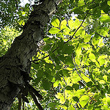 | Shagbark Hickory  Carya ovata | 60'-80' | Moist to dry | Sun to partial sun | Spring flowering, fall leaf color, shade and cooling. | Hickories, also oaks, beeches, and walnuts, supply the protein for vertebrate wildlife; cavities in living and dead trees for nesting sites; 235 spp. of caterpillars.
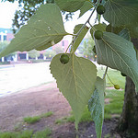 | Hackberry  Celtis occidentalis | 40'-60' | Moist to very dry | Sun to partial sun | Fast grow-  ing; good substitute for Ameri- can Elm, ornamental and well- suited as a park tree or street tree. | Excellent wildlife tree; nectar and pollen; food for breeding, migrat- ing, & wintering birds, humans; several important butterfly species develop only on Celtis.
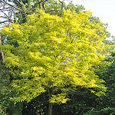 | Thornless Honeylocust  Gleditsia triacanthos inermis | 30'-70' | Moist to very dry | Sun to partial shade | Lacy foliage, attractive tree; tolerates drought, road salt, good yellow fall color. | Pollen/nectar; cover, nesting sites; silver-spotted skipper butterfly larvae, bicolored honey locust moth larvae; pods eaten by mammals.
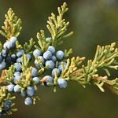 | Eastern Red Cedar  Juniperus virginiana | 36'-72' | Medium to dry | Sun to shade | Dense, slow grow-ing ever- green, DIO-ECIOUS, berries in fall; used to flavor gin; wind/visual screening. | Excellent cover; waxy berries important food for many bird spp., esp. Cedar waxwings, small mammals; foliage supports many specialist butterflies.
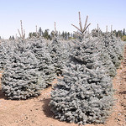 | White Spruce  Picea glauca | 30'-60' | Moist to dry | Sun to partial shade | Coniferous evergreen, cones ~ 2”, cold hardy, climax can-opy tree; fragrant, shade/  cooling, screening. | For mammals and birds, nest-ing, thermal and escape cover; food for mammals and birds, food for insect larvae, as Columbia silk-moth caterpillar.
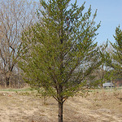 | Jack Pine  Pinus banksiana | 50'-75' | Medium to dry | Sun | Coniferous evergreen; used as Xmas trees, telephone poles;stabi-lization of watersheds; shade and cooling. | Habitat and breeding for endangered Kirtland’s Warb-ler; deer and rabbits browse, small mammals and birds eat the seeds; food for caterpillars.
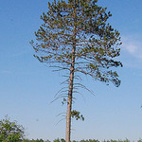 | Red Pine  Pinus resinosa | 50'-60' | Moist to dry | Sun to partial sun | Spring flowering; intolerant of shade, good in windy sites, roots anchor; long-lived; shade/cool. | Cover for wildlife; nesting sites, food for songbirds, gamebirds, small mammals; food for caterpillars, as Northern Pine Sphinx Moth larvae.
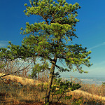 | Pitch Pine  Pinus rigida | 40'-70' | Dry | Sun | Spring blossoms; screening, shade and cooling. | Cover for wildlife, nesting sites; seeds for winter, breeding birds, migrants, mammals; supports 210 spp. of caterpillars, including Pine-devil Moth larvae
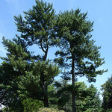 | Eastern White Pine  Pinus strobus | 60'-80' | Moist to dry | Sun to partial shade | Used for screening, shade and cooling; sequesters carbon. | As above, seeds provide significant wintering food for many mammals and birds; supports 210 species of caterpillars.
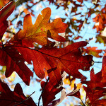 | White Oak  (a White Oak)  Quercus alba | 50'-80' | Medium to dry | Sun to partial sun | Medium sized, or of massive height,light grey bark; long lived, superior hardwood; water and rot resistant | Acorns smallish but sweet, valuable notably for turkeys, wood ducks, pheasants, jays, thrushes, woodpeckers, rabbits, squirrels, and deer; leaves for caterpillars.
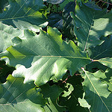 | Swamp White Oak  (a White Oak)  Quercus bicolor | 50'-60' | Very wet to upland dry to dry, variety of habitats. | Sun to partial sun | Medium-sized, rapid grower; can site plants underneath; good land-scaping tree, easily transplant-ed. | Protein rich nuts critical to vertibrate wildlife; supports 557 spp. of caterpillars; songbirds, ground birds, water birds, small mammals.
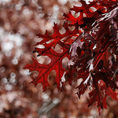 | Scarlet Oak  (a Red Oak)  Quercus coccinea | 60'-70' | Drier, sandier, usually acidic soil; or various. | Sun to partial sun | Blossoms in spring;  ornamental tree; bright scarlet foliage in fall. | As all oaks, important species for wildlife and local ecology; cover, nesting sites; food for wild turkeys, jays, woodpeckers small mammals  and caterpillars.
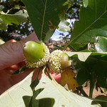 | Bur Oak  (a White Oak)  Quercus macrocarpa | 70'-80' | Wet to dry | Sun to partial sun | Massive tree, trunk up to 10’; gardens, parks, street trees; toler-ates urban conditions, outstanding ornamental | As all oaks, a most important species; long lived, sequesters carbon; fire resistant; gives food, cover and shelter to insects, birds, mammals and humans.
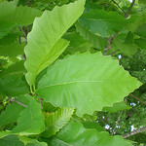 | Chinkapin Oak  (a White Oak)  Quercus muehlenbergii | 60'-70' | Moist to dry; will grow on well-drained slopes. | Sun to partial sun | Spring blooms; smaller tree, durable hardwood prized for lumber. | Sweetest acorns of any oak, excellent taste for both people and wildlife; hummingbirds, gray hairstreak butterfly larvae; as all oaks,  important tree species.
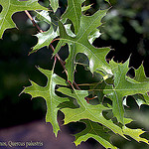 | Pin Oak  (aka Spanish Swamp Oak)  (a Red Oak)  Quercus palustris | 60-70' | Wet to dry; wetland tree can persist in heavy wet soils. | Sun, does not tolerate shade well. | Commonly used land- scape oak; easy to transplant; pollution tolerant; distinctive shape; 10 yr. tree=26’ | Like all oaks, flowers and leafs out in late spring: songbirds, water birds, ground birds, small mammals, hummingbirds, gray hairstreak butterfly larvae
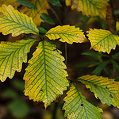 | Chestnut Oak  (a White Oak)  Quercus prinus,  Quercus montana | 50'-70' | Medium to dry, can grow in rocky ridge ex-posures. | Sun to partial shade | Spring blooms; fall color; usually not large but long lived; allows for understory tree plantings. | As above, all wildlife functions; food for insects, small mammals, birds, especially wild turkeys, ruffed grouse, songbirds.
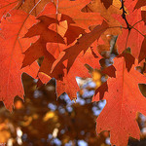 | Northern Red Oak  (a Red Oak)  Quercus rubra | 60'-75' | Moist to dry; tole-rant of many soils. | Sun to partial shade | Spring blooming; grows fast, 10 yr. tree can be 20’ tall; long lived; parks /gardens  as speci-  men tree. | All wildlife functions; iconic individuals found in Ashford, CT, Anne Arundel County, MD and Franklin County, KY; support birds, mammals, insect larvae.

Native Trees to Avoid (alphabetical by Latin species name)
Picture |  | Name | Height | Soil Moisture | Light | Blooms In | Problems
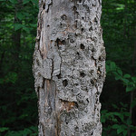 |  | American Beech  Fagus grandifolia | 50'-70' | Moist to medium | Sun to shade | Spring | Susceptible to beech bark disease (pictured).
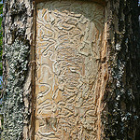 |  | True Ash Trees  Fraxinus spp. (does not include Mountain Ashes, Sorbus spp., or Prickly Ash, Aralia spinosa) | 50'-60' | Wet to very dry | Sun to partial sun | Spring | Fatally susceptible to the emerald ash borer. The characteristic damage caused by ash borer larvae is pictured.
 | 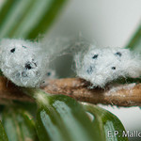 | Eastern Hemlock  Tsuga canadensis | 60'-70' | Moist to medium | Sun to shade | Spring | Fatally susceptible to the hemlock woolly adelgid (pictured).

Invasive or Potentially Invasive: Avoid/Remove (alphabetical by Latin species name)
Picture | Name | Height | Adverse Effects | Some Native Alternatives
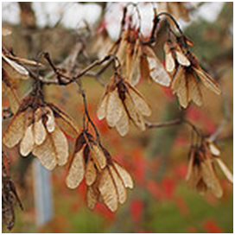   | Amur Maple: “Mozam” and all other cultivars  Acer ginnala | 15'-20' | Displaces native shrubs, understory trees in open forests and shades out native species in grassland habitats. | Pagoda Dogwood  Cornus altinfolia;  Small tree, berries, fiery fall color  Musclewood  Carpinus caroliniana;  Shade a patio, specimen, planter  Sourwood  Oxydendrum arboreum; Columnar, sweet smelling flowers, nectar, fall color
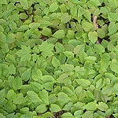 | Norway Maple:  Including “Crimson King”  and all other cultivars.  Acer platanoides | 40'-50' | Seedlings shade out native understory vegetation (pictured). Mature trees out-compete native tree species in the forest canopy. | Red Maple  Acer rubrum  Sugar Maple  Acer succharum  Black Gum  Nyssa sylvatica  Kentucky Coffeetree  Gymnocladis dioica
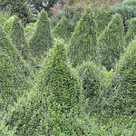 | Winter Creeper  (Climbing Euonymus) Euonymus fortunei  Burning Bush Euonymus alata  and all other cultivars | 3”-6” | E. fortuei: vigorous vine that invades forest openings and margins, displacing herbaceous plants and seedlings.  E. alata: highly competitive, displaces natives, birds disperse seeds, banned in many North Eastern states. | Bearberry, Kinnikinnick  Arctostaphylos uva-ursi  Highbush Blueberry  Vaccinium corymbosum  Red Chokeberry  Aronia melanocarpa  Fragrant Sumac  Rhus aromatica  Winged Sumac R. copallina  Smooth Sumac R. glabra
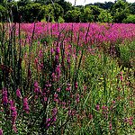 | Purple Loosestrife  Lythrum salicaria | 1’-8’ | A highly competitive invasive that outcompetes native wetland species, degrading native wildlife habitat. | Gayfeather, Blazing Star  Liatris spicata  Queen-of-the-Prairie Filipendula rubra  Swamp Milkweed  Asclepias incarnata  Blue Vervain  Verbena hastata
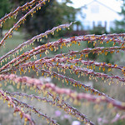 | Maiden Grass, Zebra Grass, including all cultivars  Miscanthus sinensis | 6'-8' | Forms large clumps along disturbed areas, displacing native vegetation, increases fire risks. | Indiangrass  Sorghastrum nutans  (“Gorgeous bunchgrass”, drought tolerant, gros in lean soil)  Switchgrass  Panicum virgatum  Sugarcane Plumegrass  Saccharum giganteum
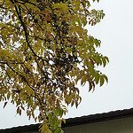 | Amur Cork Tree: “Macho” and all other cultivars  Phellodendron amurense | 30'-45' | Invades hardwood forests, displacing native species. | Tuliptree (hardy, fast grower)  Liriodendron tulipifera  Sweetgum (hardy, fast grower)  Liquidam bar stryaciflua  Black Walnut Juglans nigra  Willow Oak Quercus phellos  ServiceberryAmelanchier spp.  Red Bud Cercis Canadensis
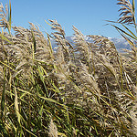 | Common Reed  Phragmites australis | 3’-6’ | Forms dense stands that exclude all other wetland species, has little value for wildlife. | (Phragmites populates disturbed areas: plant possible habitat with vigorous native species.)  Indian Grass  Sorghastrum nutans  Prairie Cordgrass  Spartina pectinata  Big Bluestem  Andropogan gerardii
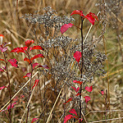 | Bradford Pear, Callery Pear:  “Jilzam,” “Cleveland Select,” and all other cultivars  Pyrus calleryana | 25'-35' | Short lifespan, structurally deficient and susceptible to storm damage; pungent smell like rotting fish; invades natural areas via hybridization or rootstock dominance, forming clumps. | Allegheny Serviceberry  Amelanchier laevis; Blossoms spring, berries summer; specimen, shade tree, hedge.  Fringe Tree  Chionanthus virginicus; Blossoms, berries (dioecious); specimen, patio, container, screen.  Green Hawthorn  Crataegus viridis; Blossoms, berries; specimen, groups.
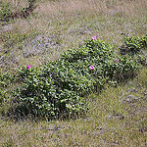 | Rugosa Rose  Rosa rugosa  Multiflora Rose  Rosa multiflora  and all cultivars of each | 4'-6' | Forms dense stands through suckering, eliminates native vegetation. | Flowering Raspberry Rubus odorata  Pasture Rose Rosa Carolina Summersweet Clethra alnifolia  Choke Cherry Prunus virginiana  Swamp Rose  Virginia Rose
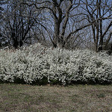 | Japanese Spiraea, including all cultivars  Spiraea japonica | 2'-3' | Invades meadows, forest openings, and disturbed areas. Prolific seed producer. | Shiney-Leaf Meadowsweet  Spiraea betulifolia;  1-3’; use as a foundation shrub, in mixed borders, or as a low hedge.  Eastern Ninebark  Physocarpus opulifolius
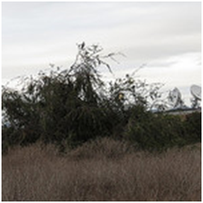 | Chinese Elm, Lacebark Elm: “Allee” and all other cultivars  Ulmus parviflora | 60'-70' | Invades native plant groups, aggressive root system absorbs water, nutrients, and space. | Winged Elm Ulmus alata  River Birch Betula nigra  Hackberry Celtus occidentalis  American Hornbeam Carpinus caroliniana  Sugarberry Celtus laevigata

References:
(In preparing this list we used the following two sources extensively: Baines, J. (2009). Native Plants for Native Birds. Ithaca, NY: Cayuga Bird Club and Darke, Rick and Tallamy, Doug. (2014). The Living Landscape. Portland, Oregon: Timber Press, Inc.)
Baines, J. (2009). Native Plants for Native Birds. Ithaca, NY: Cayuga Bird Club.
Braham, R. et al. (2002). Landscaping for Wildlife with Native Plants. Raleigh, NC: North Carolina Cooperative Extension Service.
Burrell, C.C. (2006). Native Alternatives to Invasive Plants. New York: Brooklyn Botanical Garden, Inc.
Darke, Rick and Tallamy, Doug. (2014). The Living Landscape. Portland, Oregon: Timber Press, Inc.
Emerald Ash Borer, http://www.emeraldashborer.info/ Date of access: 2014.
Engel, J.P. (2010). Using Native Plants and Ecological Design Principles in Commercial, Suburban, and Urban Landscapes. Geneva, NY: http://www.whiteaoknursery.biz.
Houston, D.R. “Major New Tree Disease Epidemics: Beech Bark Disease.” Annual Review of Phytopathology 32 (1994): 75-87. Print.
Invasive.org, http://www.invasive.org/browse/ Date of access: 2014.
Loudon Wildlife Conservancy, http://www.loudounwildlife.org/PDF_Files/Gardening_for_Wildlife_Plant_List.pdf Date of access: 2014.
Lady Bird Johnson Wildflower Center, http://www.wildflower.org/plants/ Date of access: 2014.
Leopold, D.J. (2005). Native Plants of the Northeast. Portland, OR: Timber Press.
Missouri Botanical Garden, Plant Finder Database, http://missouribotanicalgarden.org/PlantFinder/ Date of access: 2014.
"Rosa rugosa." Invasive Species Compendium. CAB International. http://www.cabi.org/isc/datasheet/47835/ Date of access: 2014.
USDA, Forest Service Northeastern Area State and Private Forestry, http://www.na.fs.fed.us/fhp/invasive_plants/weeds/ Date of access: 2014.
USDA, Natural Resources Conservation Service, PLANTS Database, http://plants.usda.gov/plantguide/ Date of access: 2014.
USDA, U.S. Forest Service, Fire Effects Information System Database, http://www.fs.fed.us/database/ Date of access: 2014.
Image Citations:
All are photographs licensed for non-commercial use via Creative Commons at http://www.flickr.com. They are listed here in order of appearance.
dogtooth77. “Actaea racemosa.” 06 Jul 2008. Online image. Flickr. 27 Oct 2014. https://www.flickr.com/photos/53817483@N00/2665590644/
Greenbelt, Rachel. “asclepias incarnata, pioneer park, jdy200 XX201407191344.jpg.” 19 Jul 2014. Online image. Flickr. 27 Oct 2014. https://www.flickr.com/photos/rachelgreenbelt/14870493872/
Mayer, Joshua. “Common Milkweed (Asclepias syriaca).” 27 Jun 2010. Online image. Flickr. 27 Oct 2014. https://www.flickr.com/photos/wackybadger/7189397964/
Josh*m. “Caltha palustris L.” 12 Jun 2010. Online image. Flickr. 27 Oct 2014. https://www.flickr.com/photos/gravitywave/4695272764/
Potterfield, Tom. “Chelone glabra (white turtlehead), inflorescence.” 17 Sep 2014. Online image. Flickr. 27 Oct 2014. https://www.flickr.com/photos/tgpotterfield/15304974956/
Gorman, Peter. “Spotted Joe Pye Weed.” 19 Aug 2012. Online image. Flickr. 27 Oct 2014. https://www.flickr.com/photos/52421717@N00/7827841752/
Magnusson, Nancy. “2013-08-03 Crimson-eyed Rosemallow 7411_6109.” 05 Aug 2013. Online image. Flickr. 27 Oct 2014. https://www.flickr.com/photos/34312269@N04/9445366443/
Paulus, Kristine. “Jewelweed.” 24 Sep 2011. Online image. Flickr. 27 Oct 2014. https://www.flickr.com/photos/kpaulus/6178923977/
Avery, Drew. “Dense Blazing Star {liatris spicata}.” 25 Jul 2009. Online image. Flickr. 27 Oct 2014. https://www.flickr.com/photos/33590535@N06/4347689892/
Mayer, Joshua. “Cardinal Flower (Lobelia cardinalis).” 09 Aug 2009. Online image. Flickr. 27 Oct 2014. https://www.flickr.com/photos/wackybadger/6247174829/
Powell, Janet. “Great blue lobelia, Lobelia siphilitica.” 20 Sep 2007. Online image. Flickr. 27 Oct 2014. https://www.flickr.com/photos/janet_powell/1423545975/
dnydick. “Untitled.” 07 Jul 2013. Online image. Flickr. 27 Oct 2014. https://www.flickr.com/photos/66842577@N08/9235926360/
Merritt, Phillip. “Peltandra Virginica Arrow Arum.” 20 May 2006. Online image. Flickr. 27 Oct 2014. https://www.flickr.com/photos/phillipmerritt/170892679/
dogtooth77. “Penstemon digitalis inflorescence.” 12 Jun 2014. Online image. Flickr. 27 Oct 2014. https://www.flickr.com/photos/53817483@N00/14290694749/
Dendroica cerulea. “Phlox.” 09 Jul 2010. Online image. Flickr. 27 Oct 2014. https://www.flickr.com/photos/dendroica/4778993046/
Sutherland, zen. “pickerel weed.” 20 Jul 2005. Online image. Flickr. 27 Oct 2014. https://www.flickr.com/photos/zen/27485820/
Sutherland, zen. “Common Arrowhead Sagittaria latifolia.” 13 Aug 2009. Online image. Flickr. 27 Oct 2014. https://www.flickr.com/photos/zen/3843476705/
Potterfield, Tom. “Scirpus ?cyperinus (woolgrass).” 16 Sep 2014. Online image. Flickr. 27 Oct 2014. https://www.flickr.com/photos/tgpotterfield/15304644518/
Falkner, Hermann. “Solidago canadensis (48°07' N 16°27' E).” 22 Sep 2011. Online image. Flickr. 27 Oct 2014. https://www.flickr.com/photos/hermannherbarium/6173269704/
chipmunk_1. “20130921 New England aster bees.” 21 Sep 2013. Online image. Flickr. 27 Oct 2014. https://www.flickr.com/photos/42919152@N04/9921373443/
Nousiainen, Kari. “Asters (Aster novi-belgii).” 11 Sep 2014. Online image. Flickr. 27 Oct 2014. https://www.flickr.com/photos/nousku/15204049266/
Anna. “Agastache foeniculum.” 14 Aug 2007. Online image. Flickr. 27 Oct 2014. https://www.flickr.com/photos/katja-london/1118557967/
Sturner, Jason. “Wild Columbine, Red Columbine (Aquilegia canadensis).” 21 May 2003. Online image. Flickr. 27 Oct 2014. https://www.flickr.com/photos/50352333@N06/4642263905/
Meeter, Jordan. “Purple Coneflower (Echinacea purpurea).” 07 Aug 2008. Online image. Flickr. 27 Oct 2014. https://www.flickr.com/photos/barefootgardener/2742128633/
Mayer, Joshua. “Black-eyed Susans (Rudbeckia hirta).” 26 Jun 2010. Online image. Flickr. 27 Oct 2014. https://www.flickr.com/photos/wackybadger/5913388941/
Reynolds, Fritz Flohr. “Campsis radicans – Trumpet Creeper.” 29 May 2012. Online image. Flickr. 28 Oct 2014. https://www.flickr.com/photos/fritzflohrreynolds/7508596014/
Nemo’s great uncle. “#6127 coral honeysuckle (ツキヌキニンドウ).” 18 Jun 2007. Online image. Flickr. 28 Oct 2014. https://www.flickr.com/photos/maynard/649133624/
Sputzer, Smabs. “Virginia Creeper.” 21 Sep 2013. Online image. Flickr. 31 Oct 2014. https://www.flickr.com/photos/10413717@N08/10058334304/
BlueRidgeKitties. “Sedum ternatum.” 17 May 2012. Online image. Flickr. 27 Oct 2014. https://www.flickr.com/photos/blueridgekitties/7238342424/
Calder, Dale. “New Brunswick Native River Grape (Vitis riparia) Hardy to Zone 2b collected and propogated by Bob Osborn at Cornhill Nursery.” 24 Aug 2011. Online image. Flickr. 27 Oct 2014. https://www.flickr.com/photos/dalecalder2003/6076618493/
Calhoun, Joe. “DSC_1991.” 08 Nov 2008. Online image. Flickr. 29 Oct 2014. https://www.flickr.com/photos/jcalhoun/3065392431/
Selkov, Gene. “Black Chokeberry.” 04 Sep 2010. Online image. Flickr. 29 Oct 2014. https://www.flickr.com/photos/selkovjr/5093691461/
Greenbelt, Rachel. “jdy198 XX20140717a1254.jpg.” 17 Jul 2014. Online image. Flickr. 29 Oct 2014. https://www.flickr.com/photos/rachelgreenbelt/14841505303/
Poyston, J. “Silky Dogwood blossom.” 10 Jun 2010. Online image. Flickr. 29 Oct 2014. https://www.flickr.com/photos/jpoyston/4710706954/
Powell, Janet E. “Cornus racemosa, Gray dogwood.” 18 Aug 2014. Online image. Flickr. 29 Oct 2014. https://www.flickr.com/photos/kyphotobug/14777535170/
Peñaloza, Rafael. “Red.” 27 Jan 2007. Online image. Flickr. 29 Oct 2014. https://www.flickr.com/photos/rpenalozan/421313500/
Keim, Mary. “Gallberry or Inkberry (Ilex glabra).” 05 Nov 2011. Online image. Flickr. 29 Oct 2014. https://www.flickr.com/photos/38514062@N03/6318827745/
Cross, Jay. “DSC03737.” 11 Dec 2013. Online image. Flickr. 29 Oct 2014. https://www.flickr.com/photos/antoniseb/11324128135/
Reynolds, Fritz Flohr. “Spicebush in Snow.” 25 Mar 2013. Online image. Flickr. 29 Oct 2014. https://www.flickr.com/photos/fritzflohrreynolds/8589613467/
Spier, Dave. “bayberry_Assateague,MD_©DaveSpier_D071323flickr.” 21 Nov 2010. Online image. Flickr. 29 Oct 2014. https://www.flickr.com/photos/dave_spier/13204839033/
Richards, F.D. “American Elderberry in Bloom.” 03 Jul 2013. Online image. Flickr. 29 Oct 2014. https://www.flickr.com/photos/50697352@N00/9202551374/
Olsen, Bryant. “Red Elderberries.” 14 Aug 2009. Online image. Flickr. 29 Oct 2014. https://www.flickr.com/photos/bryanto/3835400566/
Schäfer, Rudolf. “Schneebeere_DSC_4327.” 11 Sep 2012. Online image. Flickr. 27 Oct 2014. https://www.flickr.com/photos/schaefer-rudolf/7976193924/

Dendroica cerulea. “Indian Coralberry.” 02 Dec 2010. Online image. Flickr. 27 Oct 2014. https://www.flickr.com/photos/dendroica/5228092568/
영철 이. “블루베리 (Vaccinium corymbosum) 2014년 6월 3일.” 03 Jun 2014. Online image. Flickr. 31 Oct 2014. https://www.flickr.com/photos/bastus917/14390696911/

Kingsbrae Garden. “Viburnum dentatum, Arrowwood.” 27 Sep 2007. Online image. Flickr. 31 Oct 2014. https://www.flickr.com/photos/kingsbraegarden/1490696837/
BlueRidgeKitties. “Serviceberry.” 08 May 2014. Online image. Flickr. 20 Jan 2015. https://www.flickr.com/photos/blueridgekitties/14055235480/
Serrviceberry season.” 04 Jul 2008. Online image. Flickr. 20 Jan 2015. https://www.flickr.com/photos/suzannelong/2642460325/
rockerBOO. “02349 Pagoda Dogwood Bloom.” 18 May 2013. Online image. Flickr. 07 Nov 2014. https://www.flickr.com/photos/rockerboo/8751298990/
Richards, F.D. “Washington Hawthorn 2014.” 21 May 2014. Online image. Flickr. 31 Oct 2014. https://www.flickr.com/photos/50697352@N00/14234294111/
Cooper, Paul. “Early Crabapple.” 03 Aug 2013. Online image. Flickr. 31 Oct 2014. https://www.flickr.com/photos/29261037@N02/9430211043/
Richards, F.D. “Crabapple Tree.” 26 Apr 2010. Online image. Flickr. 15 Jan 2015. https://www.flickr.com/photos/50697352@N00/4554399569
Born1945. “Chokecherry Berries.” 19 Jul 2012. Online image. Flickr. 31 Oct 2014. https://www.flickr.com/photos/12567713@N00/7607420956/
Josh*m. “Ptelea trifoliata.” 27 Oct 2007. Online image. Flickr. 31 Oct 2014. https://www.flickr.com/photos/gravitywave/1763269170/
McCormack, Anne. “Smooth Sumac.” 24 Oct 2010. Online image. Flickr. 31 Oct 2014. https://www.flickr.com/photos/mccormacka/5174463739/
Kreger, Regina. “Staghorn sumac.” 02 Aug 2014. Online image. Flickr. 31 Oct 2014. https://www.flickr.com/photos/96662085@N03/14821932755/
Cutler, Wendy. “44-20120828_UBCBG_SorbusAffAmericana_Cutler_P1310416.” 28 Aug 2012. Online image. Flickr. 31 Oct 2014. https://www.flickr.com/photos/wlcutler/7934547838/
Smith, Wendell. “nannyberries.” 09 Oct 2013. Online image. Flickr. 31 Oct 2014. https://www.flickr.com/photos/95661536@N05/10332080305/
Illig, David. “Acer rubrum, Red Maple.” 18 Oct 2013. Online image. Flickr. 31 Oct 2014. https://www.flickr.com/photos/primeval/10352616344/
McFarland, Kent. “Sugar Maple (Acer saccharum) samara and leaf.” 18 Jun 2011. Online image. Flickr. 31 Oct 2014. https://www.flickr.com/photos/vtebird/8421795457/
Maggie. “Betula nigra ‘Cully.’” 01 Nov 2007. Online image. Flickr. 31 Oct 2014. https://www.flickr.com/photos/13389908@N03/1821616584/
dnydick. “Untitled.” 28 Sep 2013. Online image. Flickr. 01 Nov 2014. https://www.flickr.com/photos/66842577@N08/10008657356/
Sagor, Eli. “Green fruit on hackberry in St Paul, June 2 2014.” 02 Jun 2014. Online image. Flickr. 01 Nov 2014. https://www.flickr.com/photos/esagor/14328988695/
Jones, Jean. “Gleditsia triacanthos 'Sunburst.'” 11 Jun 2013. Online image. Flickr. 02 Nov 2014. https://www.flickr.com/photos/flamingparrot/9067624636/
dogtooth77. “Juniperus virginiana berries V.” 29 Nov 2011. Online image. Flickr. 02 Nov 2014. https://www.flickr.com/photos/53817483@N00/6645116981/
Bolin, Mark. “picea glauca bizon blue (2).” 24 Jul 2011. Online image. Flickr. 02 Nov 2014. https://www.flickr.com/photos/42299627@N03/6144802996/
Sagor, Eli. “Young open grown jack pine, Brainerd MN.” 27 Apr 2007. Online image. Flickr. 02 Nov 2014. https://www.flickr.com/photos/esagor/481242246/
Sagor, Eli. “Large red pine, Cloquet MN.” 12 Jun 2007. Online image. Flickr. 02 Nov 2014. https://www.flickr.com/photos/esagor/559990864/
Tonelli, Nicholas A. “Pitch Pine.” 11 Nov 2012. Online image. Flickr. 02 Nov 2014. https://www.flickr.com/photos/nicholas_t/8177521786/
Wirth, Geneva. “DSC08571.” 19 Jun 2004. Online image. Flickr. 02 Nov 2014. https://www.flickr.com/photos/gwirth/2856788128/
Dendroica cerulea. “Light through White Oak.” 06 Nov 2010. Online image. Flickr. 14 Nov 2014. https://www.flickr.com/photos/dendroica/5152934216/
-adrienne-. “Quercus bicolor.” 13 Oct 2013. Online image. Flickr. 02 Nov 2014. https://www.flickr.com/photos/photosbyadrienne/10261835323/
Severinghaus, Steven. “Fall Oak Leaves.” 20 Nov 2011. Online image. Flickr. 03 Nov 2014. https://www.flickr.com/photos/horsepunchkid/6373661787/
Lavin, Matt. “Quercus macrocarpa.” 06 Sep 2009. Online image. Flickr. 03 Nov 2014. https://www.flickr.com/photos/plant_diversity/5108085936/
Burns, Mary PK. “Chinkapin Oak.” 17 Apr 2010. Online image. Flickr. 03 Nov 2014. https://www.flickr.com/photos/maryburns/4581486247/
Vincente, Manuel Martin. “Roble de los pantanos, Quercus palustris.” 27 May 2014. Online image. Flickr. 03 Nov 2014. https://www.flickr.com/photos/martius/14304984113/
Potterfield, Tom. “Quercus prinus (chestnut oak).” 26 Oct 2011. Online image. Flickr. 03 Nov 2014. https://www.flickr.com/photos/tgpotterfield/6957763715/
Pena, António. “autumn colors12.” 12 Nov 2007. Online image. Flickr. 03 Nov 2014. https://www.flickr.com/photos/anpena/2052601250/
Sagor, Eli. “Advanced beech bark disease on a dead beech tree, White Mountains, New Hampshire.” 05 Aug 2010. Online image. Flickr. 03 Nov 2014. https://www.flickr.com/photos/esagor/4874009132/
jessica_mcp. “P1060931.” 15 Apr 2010. Online image. Flickr. 03 Nov 2014. https://www.flickr.com/photos/97794229@N00/8626890562/
B Mlry. “20110322_EPM_0013 Hemlock Woolly Adelgid-2.jpg.” 22 Mar 2011. Online image. Flickr. 03 Nov 2014. https://www.flickr.com/photos/epmallory3/5572334280/
Richards, F.D. “Amur Maple.” 24 Oct 2014. Online image. Flickr. 03 Nov 2014. https://www.flickr.com/photos/50697352@N00/10475826095/
Gaedtke, Sven. “sehr dichter Ahornwald.” 01 May 2012. Online image. Flickr. 03 Nov 2014. https://www.flickr.com/photos/jelaninemorivagus/13353784123/
Jodi. “Euonymus Fortunei ‘Minimus.’” 02 Jul 2005. Online image. Flickr. 03 Nov 2014. https://www.flickr.com/photos/squirmelia/23847562/
Vilseskogen. “saturated pink - a field of purple loosestrife.” 10 Aug 2013. Online image. Flickr. 07 Dec 2014. https://www.flickr.com/photos/vilseskogen/9584908215/
Stephen. “zebra grass seeds.” 09 Oct 2006. Online image. Flickr. 03 Nov 2014. https://www.flickr.com/photos/weretable/265554946/
Cutler, Wendy. “16-2_20121030_Alberta46th_PhellodendronAmurense_Cutler_P1350653.” 30 Oct 2012. Online image. Flickr. 03 Nov 2014. https://www.flickr.com/photos/wlcutler/8202268950/
Lavin, Matt. “Phragmites australis.” 04 Oct 2013. Online image. Flickr. 07 Dec 2014. https://www.flickr.com/photos/plant_diversity/10160968504/
Hausken, Randi. “Fjellgran.” 04 April 2007. Online image. Flickr. 03 Nov 2014. https://www.flickr.com/photos/randihausken/454263076/
Potterfield, Tom. “Invasive Pyrus calleryana (callery pear).” 30 Nov 2011. Online image. Flickr. 03 Nov 2014. https://www.flickr.com/photos/tgpotterfield/7004509398/
Manners, Malcolm. “Rosa rugosa.” 20 Jul 2009. Online image. Flickr. 03 Nov 2014. https://www.flickr.com/photos/mmmavocado/9341260465/
mommy peace. “spirea and japonica.” 25 Mar 2007. Online image. Flickr. 03 Nov 2014. https://www.flickr.com/photos/shaughnessy/2356135904/
stonebird. “IMG_2498.” 12 Nov 2011. Online image. Flickr. 03 Nov 2014. https://www.flickr.com/photos/stonebird/6343078249/

